# LAB ASSIGNMENT-19

Task-1:

Code and Output: Python program:

Write a Python function print_numbers() that prints the first 10 natural numbers using a loop.

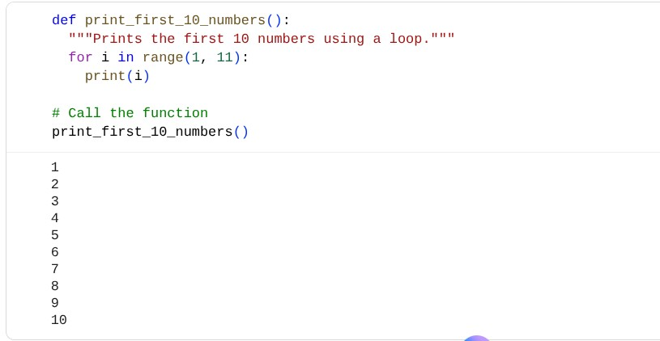

Java program:

write a program in Java to print from 1 to 10 having class name mai

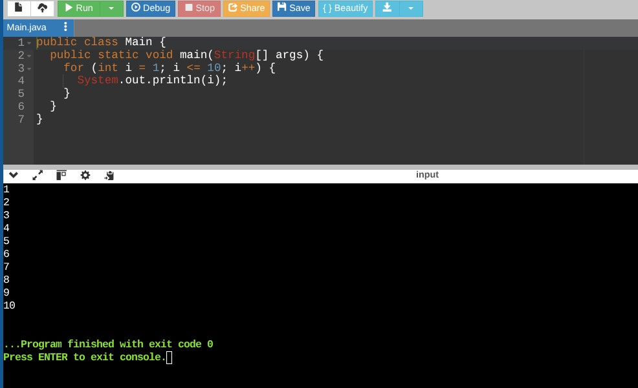

Task-2:

Code and Output:

Java program:

Write a Java method checkNumber(int num) that checks if a number is positive, negative, or zero.

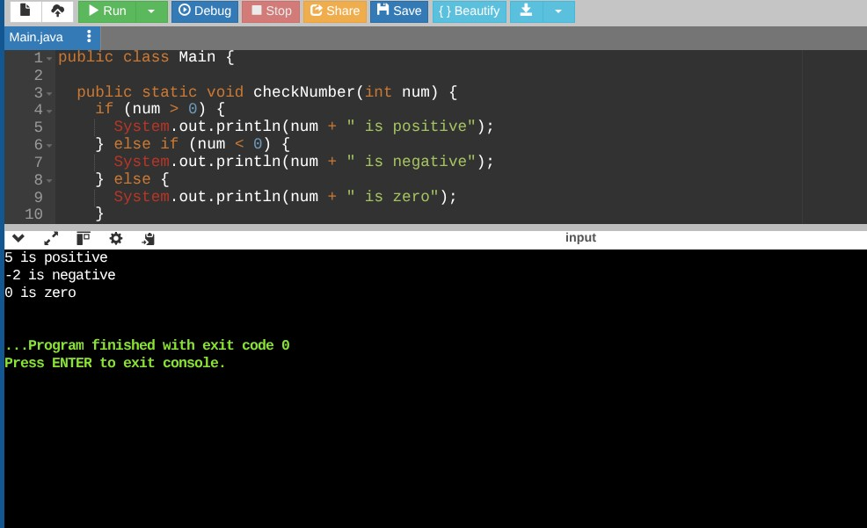

Python program:

write a program in python that checks a number is positive,negative or zero

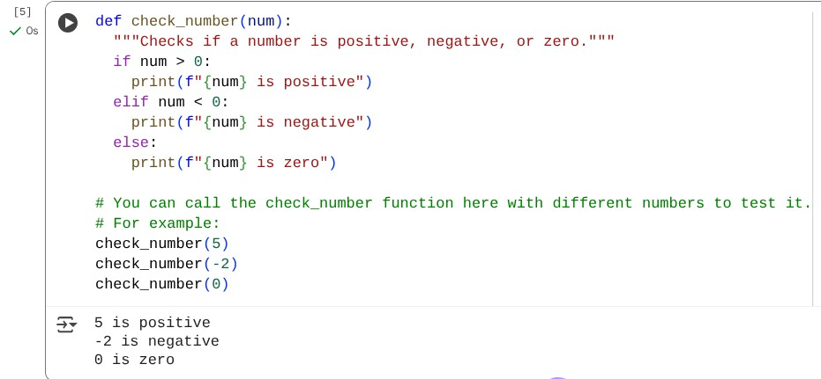

Task-3:

Code and Output:

Python program:

Write a Python function factorial(n) that calculates factorial of a number using recursion.

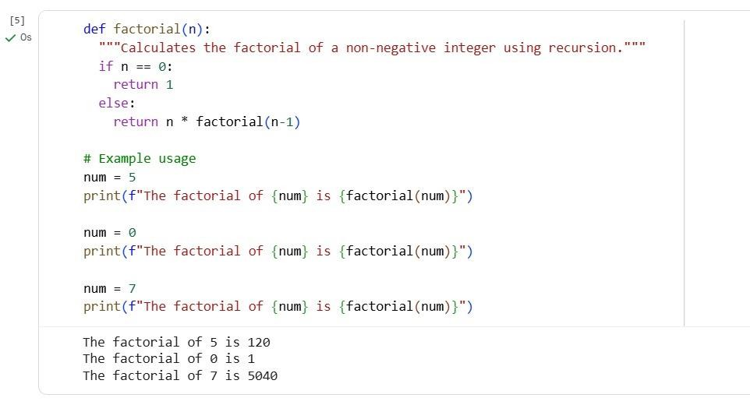

C++ program:

write a program in c++ function int factorial(int n)

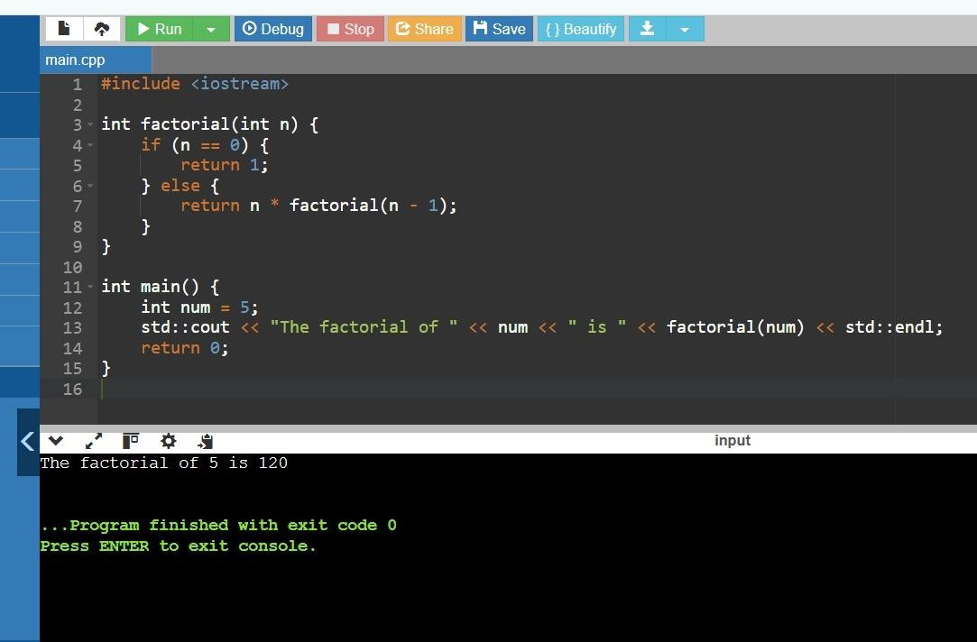

Task-4:

Code and Output:

Javascript program:

Write a JavaScript function printStudents(students) that takes an array of student names and prints each name.

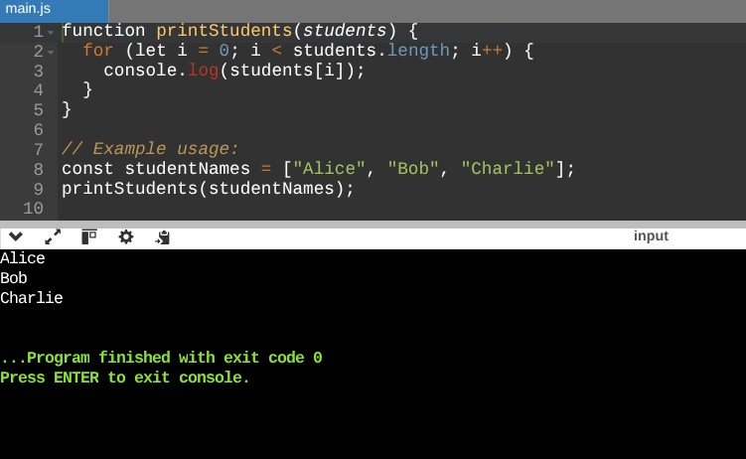

Python program:

write a python function print_students(students) using a list.

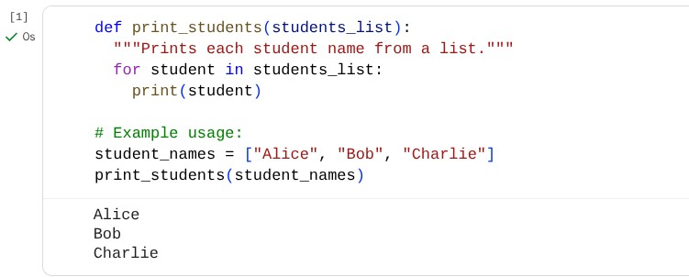

Task-5:

Code and Output:

Python program:

Write a Python class Car with attributes: brand, model, year. Add a method display_details() that prints car details.

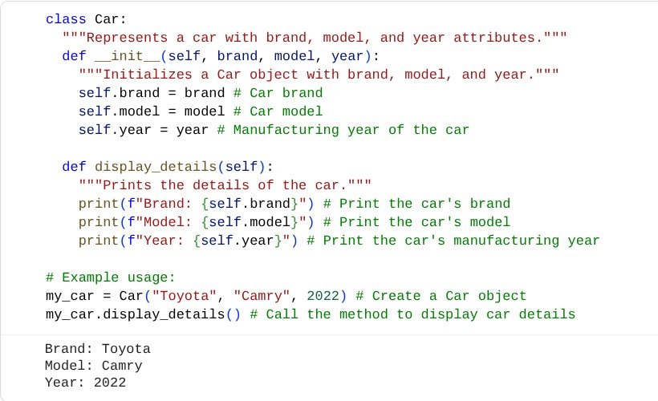

Java program:

write a Java program with class car with attributes and a method displayDetails()

